Dave Ng

Exploration of Topic Modelling using NLP Techniques

Table of Contents
1. Introduction 2
2. Data Source 2
2.1 Pre-processing 2
2.1.1 Pre-processing Workflow 2
3. Topic modelling building and explanation 3
3.1 Latent Dirichlet Allocation (LDA) 3
3.2 BERTopic 3
4. Unsupervised topic modelling evaluation 4
5. Topic Modelling Results, Visualization, and Interpretation 5
5.1 Intertopic Distance Map 5
5.2 Hierarchical Clustering 6
5.3 Topic Word Scores 7
5.4 Temporal Analysis (Topics over Time) 8
5.5 Topic-Sentiment Cross-Analysis (Heatmap) 9
6. Conclusion 9
6.1 Limitations and Future Work 10
7. References 11

Introduction
The rise of social media platforms like Twitter has transformed public discourse, providing a real-time arena for individuals to express opinions on global issues. Climate change remains a highly debated topic characterized by varying degrees of scientific advocacy, political polarization, and skepticism. This report explores the identification of abstract thematic "topics" within a large corpus of climate-related tweets using Natural Language Processing (NLP) and machine learning techniques. By employing Latent Dirichlet Allocation (LDA) and BERTopic, this study aims to uncover the underlying narratives, assess the quality of these discovered themes, and interpret the sentiment landscape of the climate change conversation between 2015 and 2018.

Data Source
A dataset of climate change-related tweets from Kaggle is used to analyze topic modeling algorithms’ ability to distinguish between mainstream scientific discourse and niche echo chambers. Twitter provides real-time data on public sentiment and reactions to policy changes and natural disasters.

2.1 Pre-processing
Each tweet in the dataset was independently labeled by three reviewers into four sentiment categories: Pro (1), News (2), Neutral (0), and Anti (-1). To prepare the text for modeling, a rigorous pre-processing pipeline was implemented:
- All text was converted to lowercase to standardize the input.
- URLs, usernames, and "RT" strings were stripped from the messages.
- Non-alphanumeric characters and extra spaces were removed.
- Standard English stopwords were filtered out to remove low-value terms.
- The remaining words were lemmatized using the WordNetLemmatizer to reduce them to their base vocabulary forms.

2.1.1 Pre-processing Workflow
- Noise Removal: Hyperlinks, Twitter handles (mentions), and the "RT" (retweet) tag were removed to focus on original content.
- Normalization: All text was converted to lowercase, and non-alphabetic characters were stripped.
- Tokenization & Stop-word Filtering: Sentences were split into individual words, and common English stop-words were removed to highlight meaningful terms.
- Lemmatization: Words were reduced to their base using the WordNet Lemmatizer to group related terms together.
- Following these steps and removing duplicate "clean" messages, the final dataset for analysis consisted of 37,926 unique tweets.

Topic modelling building and explanation
LDA and BERTopic methodologies were used to identify topics.

3.1 Latent Dirichlet Allocation (LDA)
LDA, a statistical method, assumes documents are mixtures of topics (Blei, D. M., Ng, A. Y., & Jordan, M. I.), which are mixtures of words. A coherence sweep determined the optimal number of topics (k) from 5 to 50.
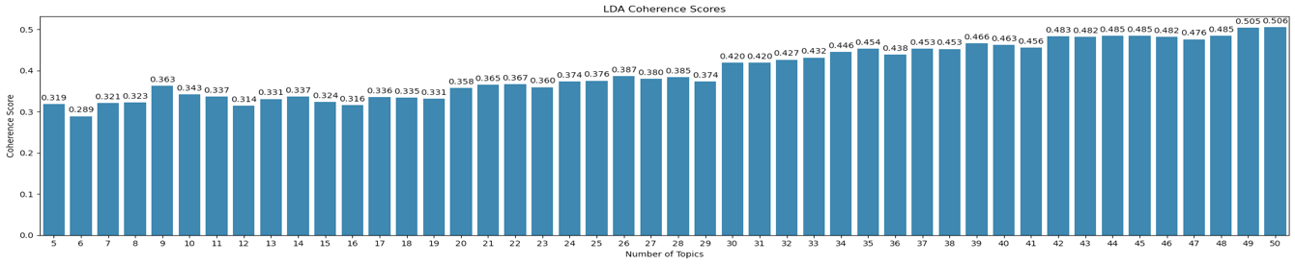
Figure 8—Top 10 Common Word % (News)
- Optimization: From Figure 8, while coherence peaked at 48 topics, k=31 was chosen using the "elbow" method to balance granularity with human interpretability.
- The pre-processed text was tokenized, and a Gensim dictionary was created, systematically filtering out extreme words.

3.2 BERTopic

n_neighbors | min_cluster_size | n_gram_range | cv_score | num_topics | outlier_count | outlier_percentage
i64 | i64 | list[i64] | f64 | i64 | i64 | f64
15 | 80 | [1, 3] | 0.5264 | 65 | 12093 | 31.89
15 | 65 | [1, 3] | 0.5155 | 76 | 12324 | 32.49
20 | 80 | [1, 3] | 0.5111 | 65 | 11292 | 29.77
10 | 80 | [1, 3] | 0.504 | 69 | 13207 | 34.82
15 | 80 | [1, 2] | 0.5016 | 65 | 12093 | 31.89
… | … | … | … | … | … | …
20 | 15 | [1, 2] | 0.4158 | 295 | 14627 | 38.57
10 | 15 | [1, 2] | 0.4106 | 325 | 11520 | 30.37
10 | 15 | [1, 3] | 0.409 | 325 | 11520 | 30.37
15 | 15 | [1, 2] | 0.408 | 313 | 15089 | 39.79
15 | 15 | [1, 3] | 0.408 | 313 | 15089 | 39.79
Table 1— Gridsearch results of BertTopic

The grid search in table 1 evaluates different combinations of three parameters to balance the semantic coherence of the generated topics against the number of outliers produced. n_neighbors dictates the UMAP model's structure, min_cluster_size sets the strictness for HDBSCAN clustering, and n_gram_range determines the word sequences extracted by the CountVectorizer. Modifying these parameters affects the model by altering the trade-off between achieving the highest possible Coherence Score and keeping the outlier percentage below a targeted acceptable threshold.
BERTopic is a modern deep learning approach that utilizes transformer-based embeddings (Reimers, N., & Gurevych, I.).
- Embeddings: The all-MiniLM-L6-v2 (Hugging Face 2022) model was used to generate sentence-level embeddings.
- Clustering: UMAP (McInnes, L., Healy, J., & Melville, J) was used for dimensionality reduction and HDBSCAN (Reimers, N., & Gurevych, I.) for clustering.
- Parameter Tuning: The best model parameters are n_neighbors=15, min_cluster_size=80, and n_gram_range=[1,3], yielding a coherence score of 0.5264 and a 31.89% outlier rate. A better trade-off is n_neighbors=20, min_cluster_size=80, and n_gram_range=[1,3], achieving a 29.77% outlier rate and a coherence score of 0.5111 shown in table 1.
In the context of this of this dataset, utilizing the maximum tested min_cluster_size of 80 (cluster strictness) indicates the model required a high minimum threshold of tweets to form a distinct topic, to prevent the ~38,000 tweets from fragmenting into hundreds of incoherent micro-topics. Furthermore, an n-gram range up to 3 was necessary to capture the multi-word phrases that are fundamental to climate change discourse, n_neighbors parameter controls the "UMAP local vs global structure" and the model does suggest that it is more to a global structure.

Unsupervised topic modelling evaluation
The quality of the models was measured using Coherence Score, which quantifies the semantic similarity of high-scoring words within a topic.
Model | Coherence Score (Cv​) | Topic Count | Quality Observation
LDA (k=31) | 0.4490 | 31 | Reasonable semantic grouping, some overlapping themes.
BERTopic | 0.5111 | 65 | Higher semantic density, better at isolating niche conversations.
Table 2—Evaluation of Topic Model Results

5. Topic Modelling Results, Visualization, and Interpretation

5.1 Intertopic Distance Map
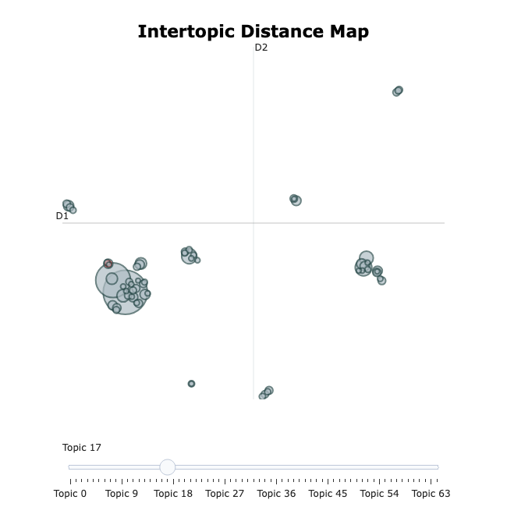
Figure 9— Intertopic distance map from Bertopic
The intertopic distance map (Figure 9) shows a large cluster of overlapping circles in the lower-left quadrant indicates semantic similarity among 65 topics, representing mainstream discourse on climate change.
Niche Conversations: several smaller, tightly grouped, or isolated clusters scattered away from the main group (e.g., in the middle-right, top-right, and far-left). These represent conceptually distinct conversations that do not share much vocabulary with the main discourse. These might relate to very specific news events, localized phenomena, or distinct political narratives such as the "Chinese hoax" or specific political figures.
Many of the 65 topics are not entirely isolated from one another. The visual overlap suggests that users fluidly mix terms from various sub-topics when discussing the broader issue of climate change.

5.2 Hierarchical Clustering
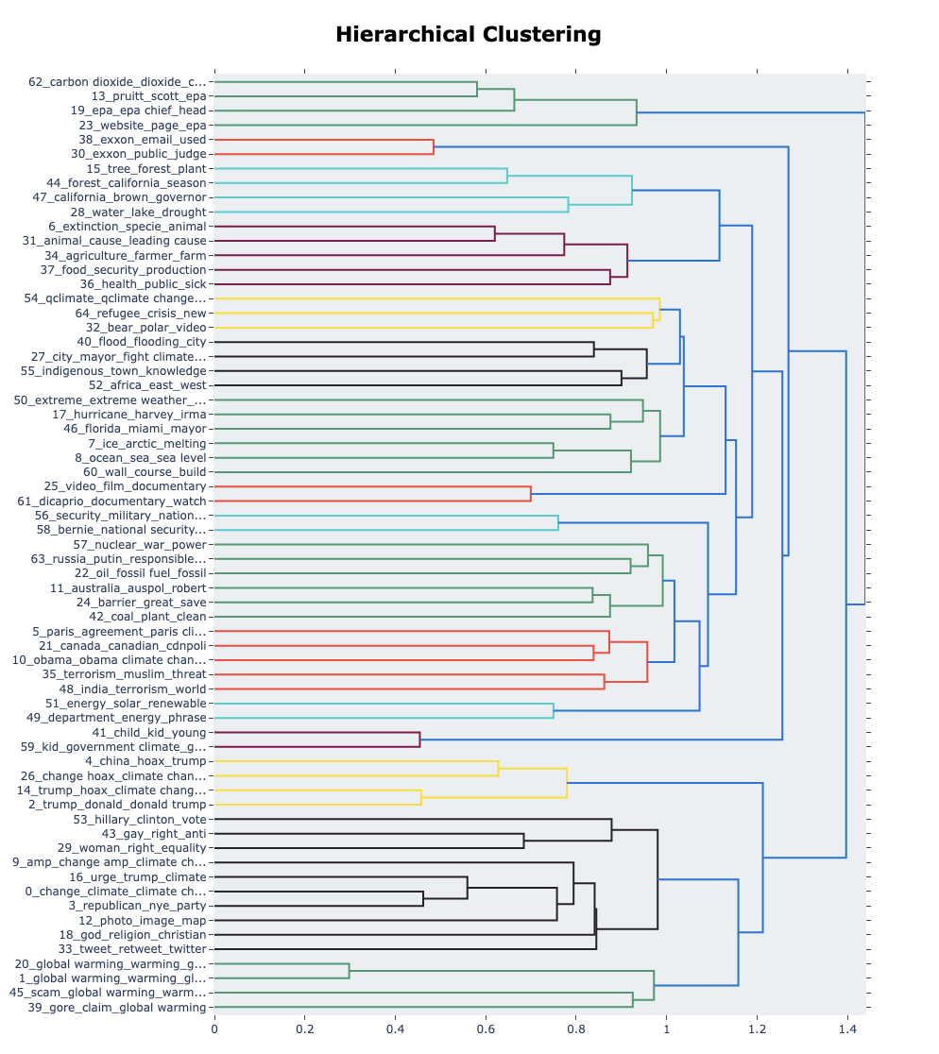
Figure 10— Hierarchical Clustering from Bertopic
The hierarchical clustering dendrogram in figure 10, cohesive narrative branch that directly links Trump, China, and skepticism/hoax rhetoric. Additionally, it effectively groups distinct conversation branches regarding impacts like floods and hurricanes, US environmental policy (EPA), and outright denial.

Topic Word Scores
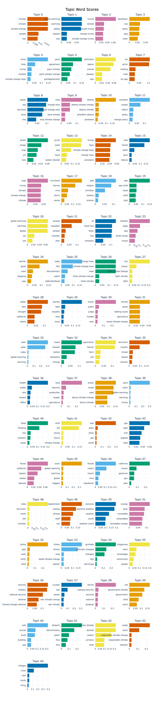
Figure 11— Topic Word Scores from Bertopic
BERTopic analysis of 65 climate change topics reveals dominant thematic clusters, including physical consequences, political narratives, and energy policy. The model effectively distinguishes between similar issues and identifies vocabulary distinctiveness, sentiment indicators, and granular sub-topics.

Topic word scores in Figure 11 reveal the model’s success in creating specific thematic clusters and indicate sentiment, with “science” and “real” showing a pro-climate stance and “hoax” and “scam” indicating an anti-climate stance.

Temporal Analysis (Topics over Time)
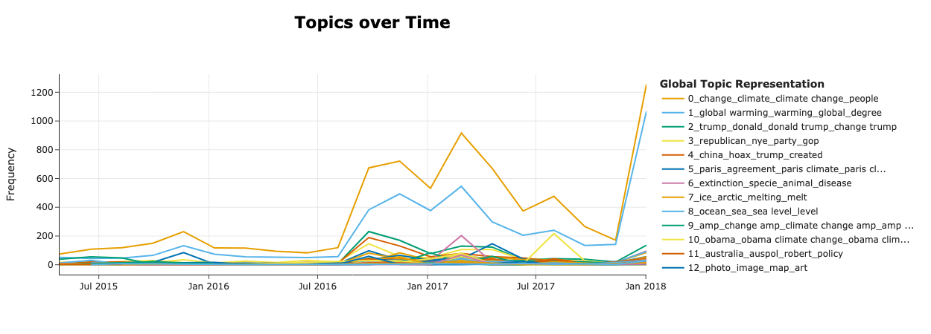
Figure 12— Temporal Analysis from Bertopic

Tracking topic frequency, in Figure 12, Twitter discussions on climate change are event-driven, with significant spikes correlating to real-world events like the 2016 US Presidential Election and the US withdrawal from the Paris Agreement. Broad topics like “climate change” and “global warming” dominate the discourse, absorbing most of the volume during major events.

5.5 Topic-Sentiment Cross-Analysis (Heatmap)
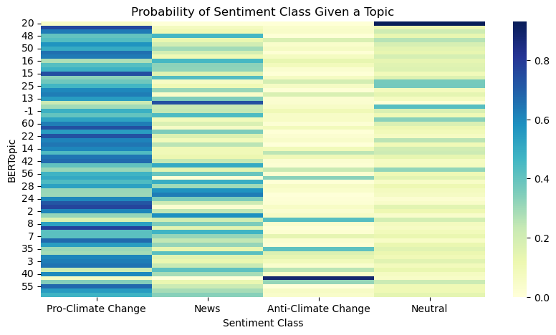
Figure 13— Temporal Analysis from Bertopic

The heatmap (Figure 13) shows a dominance of "Pro-climate change" sentiment, confirming the dataset's heavy skew toward pro-climate discourse. Crucially, it shows that "anti-climate change" sentiment is not evenly spread but is highly concentrated in very specific conversational silos with distinct vocabulary, showing very little blending with mainstream reporting.
“News” column has concentrated dark blue spots at Topic 59 and Topic 38, representing pure news reporting.
The “Neutral” column is sparse with a dark blue block for Topic 20, indicating a cluster of conversation avoiding taking a stance.

6. Conclusion
This study successfully applied Natural Language Processing (NLP) and machine learning to extract and interpret thematic "topics" from a large corpus of climate-related tweets. The comparative analysis demonstrated that BERTopic provided a superior, more nuanced representation of the data than LDA, identifying 65 distinct thematic clusters with higher semantic density.
The findings reveal a discourse deeply intertwined with US politics, where scientific consensus often competes against "hoax" narratives within isolated conversational silos. Furthermore, the temporal analysis confirmed that climate discourse on Twitter is highly episodic, primarily driven by immediate reactions to policy shifts, such as the Paris Agreement withdrawal, and natural disasters.

6.1 Limitations and Future Work
Despite the successful extraction of topics, this study has certain limitations:
- Temporal Scope: The analysis was restricted to data between 2015 and 2018, which may not reflect current shifts in the climate narrative.
- Platform Bias: The results are specific to Twitter users and may not be representative of the broader public opinion on other social media platforms.
- Methodological Constraints: While BERTopic performed well, the 29.77% outlier rate suggests that a significant portion of the text was not assigned to a specific topic, potentially overlooking niche sentiments.
Future work could expand the study by incorporating datasets from 2020-2025 to examine how global events, such as COVID-19 and Trump's second term, have reshaped the climate conversation.

7. References
Blei, D. M., Ng, A. Y., & Jordan, M. I. (2003). Latent Dirichlet Allocation. Journal of Machine Learning Research, 3, 993–1022. https://www.jmlr.org/papers/volume3/blei03a/blei03a.pdf
Gensim. (n.d.). Gensim: Topic modeling for humans. Retrieved from https://github.com/piskvorky/gensim
Grootendorst, M. (2022). BERTopic: Leveraging BERT and a class-based TF-IDF to create easily interpretable topics. https://arxiv.org/abs/2203.05794
Hugging Face. (2022). all-MiniLM-L6-v2 Sentence Transformer. Retrieved from https://huggingface.co/sentence-transformers/all-MiniLM-L6-v2
Kaggle. (2020). Twitter Climate Change Sentiment Dataset. Retrieved from https://www.kaggle.com/datasets/edqian/twitter-climate-change-sentiment-dataset
McInnes, L., Healy, J., & Melville, J. (2018). UMAP: Uniform Manifold Approximation and Projection for Dimension Reduction https://arxiv.org/abs/1802.03426
Reimers, N., & Gurevych, I. (2019). Sentence-BERT: Sentence Embeddings using Siamese BERT-Networks https://arxiv.org/abs/1908.10084

